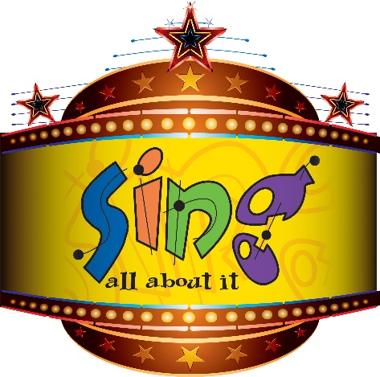

Sioux City East High Choirs
Event Chair Contacts: Christie Finnegan (Cell: 712-899-2950) & Amy Nilles (Cell: 712-898-5630)

East High Hosts 31st Annual Sing All About It! Show Choir Invitational
Show choirs from the tri-state area to compete.

Sioux City East High Choirs will host their “Sing All About It!” show choir invitational on Saturday, March 2nd at East High School. The competition will feature 8 competing middle school show choirs and 15 competing high school show choirs representing 13 different schools from the tri-state area. A three-time FAME Aspire nominated competition and national Aspire Award Winner in 2019, Sing All About It! is celebrating its 31st anniversary this year. Both middle school and high school choirs are competing for the grand champion trophy in their division as well as other honors.

The middle school show choir competition begins at 8:00am, with Sioux City East Middle’s Sparks Show Choir opening the event in the East High Auditorium. East Middle’s Evolution Show Choir will conclude the middle school competition and perform in exhibition at 11:10am. The middle school awards ceremony will then be held at 11:45am.

The high school competition begins at 8:00 am in the East High Gym. East High School’s show choir, Entourage, performs in exhibition at 12:30pm. East High’s show choir, Prestige, will also perform in exhibition at 5:15pm with high school preliminary awards following at approximately 5:45pm. Six high school show choirs will move to the finals starting at 6:45pm. The Headliners will take the stage for their exhibition performance at 9:45pm with the final awards ceremony being held immediately following at 10:15pm.

In addition to providing a quality competition for middle and high school show choirs, Sing All About It! is also the largest fundraising event for the East High Show Choir program. Admission is $15 and $10 for students with ages 5 and under free. Concessions are available all day offering attendees breakfast, lunch, dinner, and a variety of snacks. In addition to parking at East High School, there will be overflow parking available one block away at Sunnybrook Church (5601 Sunnybrook Drive) and with a free shuttle available the entire event continuously going back and forth between the two locations. The public is encouraged to come out to enjoy an inexpensive day of musical entertainment showcasing some of the most talented singers, dancers, and show band musicians in the region.

The performance schedule and more information about Sing All About It! can be found here: http://www.siouxcityeastchoir.com/sing.

###

About East High Show Choirs
East’s three show choirs – The Headliners (Varsity), Prestige & Entourage – are active on the competitive show choir circuit, and the program constitutes the largest extra-curricular organization anywhere in Sioux City with nearly 170 students in the program. Now in its 35th year, The Headliners have received more than 50 Grand Champion awards and innumerable captions for Best Vocals, Best Choreography, and Best Band. In 2010, they were recognized by Parade Magazine as one of America’s Favorite Show Choirs (top 3), and in 2011, were featured in choreographer Mike Weaver’s book, Sweat, Tears, and Jazz Hands: The Official History of Show Choir from Vaudeville to Glee. In 2016, The Headliners were recognized as the “Most Decorated” Show Choir in Iowa and placed 8th at Show Choir Nationals in Nashville in 2019. East High Show Choirs are under the direction of Jeremy Hess, Abby Sheppard, and Dylan Larsen. For more information visit https://www.siouxcityeastchoir.com/.

